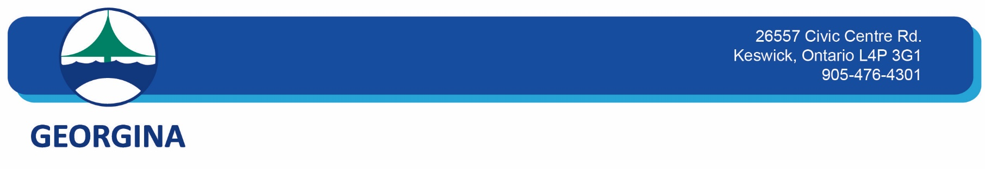

**Legislative Services Department/Clerk’s Division**

Please be advised that the Town of Georgina Council, at its meeting held on November 22, 2022, considered proposed Bill 23, the More Homes Built Faster Act, 2022 and subsequent to discussion, the following motion was passed:

Moved By Councillor Neeson  
Seconded By Councillor Genge

RESOLUTION NO. C-2022-0354

WHEREAS on November 10, 2022, York Region Council adopted a resolution as follows:

"York Region requests the Province of Ontario to halt Bill 23 and begin consultation with the Housing Supply Action Plan Implementation Team to ensure municipalities can work in partnership with the Province of Ontario over the next few months to address the housing affordability concerns in our communities.

The Minister of Municipal Affairs and Housing be requested to appoint key stakeholders, such as the Association of Municipalities of Ontario (AMO), to the Housing Supply Action Plan Implementation Team.

The Regional Clerk circulate this report, including new Attachment 5, presented as Item G.1.1 on the revised agenda, to the Minister of Municipal Affairs and Housing, local municipalities, AMO, Federation of Canadian Municipalities (FCM) and local MPPs."

AND WHEREAS Schedule 10 to Bill 23 Supporting Growth and Housing in York and Durham Regions Act, 2022 proposes to expedite the expansion and extension of the York Durham Sewage System effectively replacing the Upper York Sewage Solution (UYSS) project;

AND WHEREAS The Council of the Corporation of the Town of Georgina supports the halting of the Upper York Sewage Solutions project and the redirection of related drainage Area flows to the York Durham Sewage System;

THEREFORE BE IT RESOLVED THAT The Council of the Corporation of the Town of Georgina supports the November 10, 2022 resolution of  York Region Council concerning Bill 23, with the exception that  The Council of the Corporation of the Town of Georgina supports Schedule 10 to Bill 23 Supporting Growth and Housing in York and Durham Regions Act, 2022 which proposes  to expedite the expansion and extension of the York Durham Sewage System effectively replacing the Upper York Sewage Solution (UYSS) project;

AND FURTHER THAT The Council of the Corporation of the Town of Georgina support the resolution of the Board of the Lake Simcoe Region Conservation Authority dated November 18, 2022 directing Staff to provide a submission to  Environmental Registry of Ontario No. 019-6141 based on comments within Staff Report No. 40-22-BOD regarding Provincial Bill 23 - More Homes Built Faster Act, 2022  and that Staff be directed to submit a letter to the Minister of Natural Resources and Forestry and the Minister of Environment, Conservation and Parks requesting that the Conservation Authorities Working Group be re-engaged;

AND FURTHER THAT the Council of the Corporation of the Town of Georgina opposes the proposed removal or re-designation of approximately 7,400 acres of protected lands from the Provincial Greenbelt Area and/or the Oak Ridges Moraine Conservation Plan for residential development as set out in ERO posting number 019-6217 and ERO posting number 019-6218;

AND FURTHER THAT the Council of the Corporation of the Town of Georgina opposes the conversion of Conservation Authority lands, for housing purposes in the absence of a fuller understanding of the criteria that will be used to conduct the assessment and a Municipal Comprehensive Review that demonstrates the need for the conversion to meet population targets;

AND THAT this resolution be forwarded to the Honourable Doug Ford, Premier of Ontario, the Honourable Steve Clark, Minister of Municipal Affairs and Housing, the Honourable David Piccini, Minister of the Environment, Conservation and Parks, the Honourable Graydon Smith, Minister of Natural Resources and Forestry, Caroline Mulroney, MPP, York-Simcoe, York Region MPP’s, York Region municipalities, Lake Simcoe Watershed MPP’s, the Honourable Peter Tabuns, Leader of the Opposition and interim leader of the Ontario New Democratic Party, the Honourable John Fraser, Interim Leader of the Ontario Liberal Party, the Honourable Mike Schreiner, Leader of the Green Party of Ontario, Lake Simcoe Region Conservation Authority, Association of Municipalities of Ontario (AMO) and all Ontario municipalities.