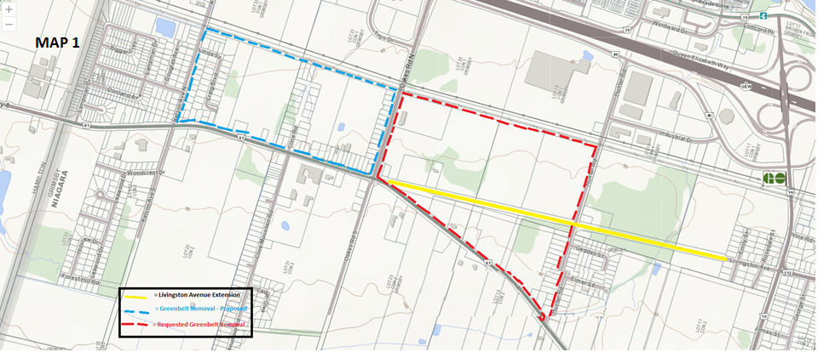

**Notes for MAP 1:**

1. Lands outlined in red, ‘Requested Greenbelt Removal’ does NOT include the land parcel known as the woodlot.
2. Land outlined in red, ‘Requested Greenbelt Removal’ is within the MTSA[1] and is bisected by the Livingston Road Extension (LAE) that will provide a roadway, pedestrian sidewalks and bicycle lane access to the future GO Train Station and 14-acre Parking Lot. **Lands outlined in blue west of Oakes is NOT in MTSA.**
3. AgPlan Limited *Specialty Crop Greenbelt Study Report for The Town of Grimsby* (2016 PDF) proves the outlined properties were incorrectly mapped as Greenbelt in the original plan.
4. Modifying the Proposed Amendments to the Greenbelt Plan to merge the 2 abutting areas shown on MAP 1 will facilitate a fast path for land owner investment to build the new and approved Grimsby GO Train Station. It is on readily serviceable land including sidewalks, water, Bell and sewer lines.
5. Right-Of-Way in yellow, ‘Livingston Avenue Extension’, is land expropriated by the region in the early 1970’s – EA was completed and approved (2020).
6. Owners within the outlined lands have made presentations to the Town of Grimsby and Region of Niagara council to have land removed from the Greenbelt.

The Province of Ontario through Metrolinx is pursuing a "Transit Oriented Communities" (TOC) program to build vibrant, higher density and mixed-use communities that are connected to transit stations. The Region of Niagara adopted a new Official Plan in June 2022 and it aligns perfectly with the TOC vision statement by using the future Grimsby GO Train Station and future LAE as its centre-piece. The LAE will provide the corridor to open much needed residential and employment lands as well as provide a conduit to the GO Train Station and the allocated 14-acre Parking Lot. Unfortunately, the lands along the LAE have been frozen by the Greenbelt.

**N.B. The lands outlined in blue on MAP 1 and west of Oakes Road currently in the provincial proposal for ‘Greenbelt Removal’ is NOT within an 800-meter radius of the GO Train Station – it does not qualify as a MTSA as defined in the Provincial Growth Plan. The lands outlined in red on MAP 1 west of Hunter Road do qualify as a MTSA (within 800-meter radius) but has not been identified for ‘Greenbelt Removal’ in the provinces proposed amendment. Those lands west of Hunter Road and along the LAE is a development area that is an ideal candidate for a complete community entirely captured within an MTSA, providing a community that is compact and walkable - yet it was not amended for ‘Greenbelt Removal’. Might this have been an oversight in the proposal that could be revisited for correction during the upcoming consultation period?**

The planning in the Region’s Transportation Infrastructure for Grimsby provides the stage to fully meet the benefits defined by Metrolinx for a TOC:

* Increasing transit ridership and reducing traffic congestion.
* Increasing housing supply (including affordable housing) and jobs.
* Catalyzing complete communities based on good planning principles.
* Offsetting the cost of station construction which would save taxpayers' money.
* Stimulating the economy through major projects for years after COVID-19.

However, these benefits can only be fulfilled if the lands between Kelson Ave to Hunter Road (including the MTSA along the LAE), as outlined in MAP 1 above, are merged together for ‘Greenbelt Removal’. **The LAE is a prime future transportation asset that has already been EA approved and is fully funded for completion.**

The study report referenced in Note 3 of MAP 1 above, by Michael K. Hoffman of AgPlan Limited provides the following conclusion:

*“The findings of this study demonstrate that the lands proposed to be removed from the specialty crop area in Grimsby are relatively poor for the production of specialty crops. Several of the tests for the designation of a specialty crop area are not met.”*

*…*

*Given the characteristics of the lands in Grimsby proposed to be removed from the specialty crop area (areas identified within this report as one and two and located north of the Niagara Escarpment), I am of the opinion that the lands can reasonably be removed from that specialty crop area designation.”*

This study report provides scientific evidence that confirms the lands outlined in MAP 1 (i.e., the 2 parcels between Kelson Ave and Hunter Road) can be removed from the Greenbelt. Removal of these lands from the Greenbelt will open lands along the essential transportation asset (future LAE) providing readily serviceable land in a MTSA within 800 meters of the future Grimsby GO Train Station.

Transit Oriented Communities (TOC) are defined as higher density, mixed-use development that is connected, next to or within a short walk of transit stations and transit stops. Metrolinx has always envisioned TOC as a key part of the region’s growth.

Implementing a TOC along the LAE on lands that have been removed from the Greenbelt (the merged and enlarged parcel of outlined lands shown in MAP 1) west of Hunter Road will provide the surrounding community the capacity to meet projected demands for:

* affordable housing for young families, an aging population, as well as providing an accessible living community for those with disability
* residents who want to live in the city they work in to reduce the burden of commuting and also eliminate the need to own a second car
* transportation hub for the GO Train and the planned future regional level consolidated passenger transit service
* parking for commuters at the 14-acre GO Train parking lot that will be accessible from the Livingston Road Extension and Casablanca Blvd
* providing a corridor for safely transporting children to daycare centres, schools like Smith School with soccer park on Oakes Road as well as Blessed Trinity High School, baseball park on Oakes Road and the Grimsby Town Hall/Community Centre/Hockey Pads (indoor and outdoor) which are all accessible via LAE
* maximizing the provincial investment for their plan to build a new Grimsby Hospital by providing a connected growing population
* the LAE will complete a separate east-west corridor link to allow first responders to more quickly report-to and transport emergency cases, especially to the new Grimsby Hospital that today has limited access from west Grimsby

Without the merged and enlarged ‘Greenbelt Removal’ area outlined in MAP 1 along the LAE, the town and region will NOT be able to find a development partner to justify the required Initial Business Case to build a GO Train Station.

The 2018-2022 term Grimsby Town Council enacted every roadblock, red-tape delay and bylaw stall tactic including forcing developers to request unnecessary OLT hearings in attempt to stop all development[2]. Examples include Grimsby Town councillors who voted against a motion to establish the future Grimsby GO Station. Also, the Town of Grimsby Council worked against the Region of Niagara to try to block enhancement of the transportation infrastructure planned by the Region by submitting a Part II Order Niagara (on July 20, 2020) in an attempt to block the regions EA for the LAE. Fortunately, the block failed and the EA was fully approved. It is unheard of for a town to turn down the significant funds for the build of a vital transportation asset and accompanying infrastructure, especially when considering the Grimsby GO Train Station was already approved.

The 2018-2022 term Grimsby Town Council had a NIMBY culture and enacted hostile attacks to much needed developments.

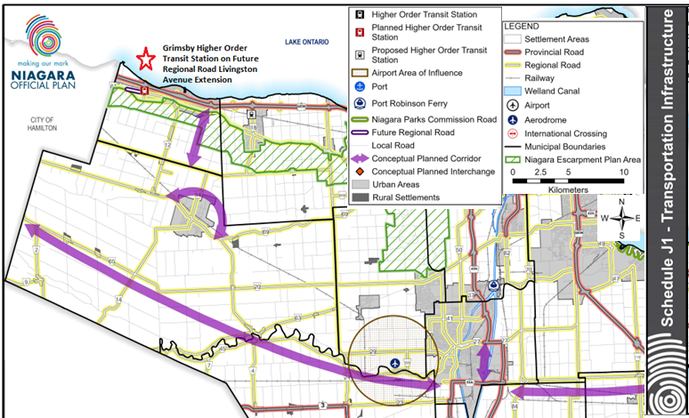

The map in **Schedule J1 - Transportation Infrastructure** of the Niagara Official Plan above shows the **Higher Order Transit Station** in west Grimsby (noted on the map with a red star). This also shows the **Future Regional Road** / LAE in the reduced scale image. This map shows the Region of Niagara has taken the positive steps needed to facilitate growth around the future Grimsby GO Train Station. Note the provincial Greenbelt Maps did not show the future LAE so it is not easily evident to the reader the infrastructure is already in place or approved for the Grimsby GO Train Station. The map in the Proposed Amendments to Greenbelt Plan issued by the province on November 4, 2022 should be updated to show this vital transportation asset the LAE.

The Greenbelt mapping around the future LAE shown in MAP 1 freezes growth, it prevents interest of developers that would partner with the town to provide an Initial Business Case to build the Grimsby GO Train Station. The Town of Beamsville plan for their GO Train Station came after the announcement in Grimsby, they have only half the population of Grimsby which is closer in proximity to the very large-populated City of Hamilton and yet they (Beamsville) managed to build the partnerships with developers to complete the Initial Business Case with Metrolinx. The Town of Grimsby council’s reluctance to build plus the lack of lands outside the Greenbelt makes it impossible to attract investment from developers. The remedy is to include lands in the MTSA for ‘Greenbelt Removal’.

The next 2 pages show Arial View #1 (Requested Greenbelt Removal) and Arial View #2 (Greenbelt Removal - Proposal). The outlined properties in these Arial Views abut one another. Only the lands outlined in Arial View #2 are included for ‘Greenbelt Removal’ in the provinces Proposed Amendments to the Greenbelt Plan issued on November 4, 2022. Note the LAE terminates at Oakes Road and does not extend into the ‘Greenbelt Removal’ land in the Proposed Amendments to the Greenbelt Plan for Grimsby. In fact, all lands in the Grimsby GO Transit MTSA along the LAE are currently included in the Greenbelt, such a waste of infrastructure.

Our session today provides the opportunity for us to:

* Convey our full endorsement for the Proposed Amendments to the Greenbelt Plan issued by the province on November 4, 2022, as referenced in the Environment Registry of Ontario (ERO Number 019-6216) Greenbelt Act 2015.
* Ask the current province for an update to the Proposed Amendments to the Greenbelt Plan to merge the lands outlined in Arial View #1 (not slated for ‘Greenbelt Removal’) to the lands outlined in Arial View #2 (proposed for ‘Greenbelt Removal’) to make a single, slightly larger zone outside the Greenbelt. This will derive the benefits of the MTSA around the Grimsby GO Train Station. The LAE is the transportation asset that drives the development for a TOC for Grimsby.
* Emphasize to the province the importance of the future transportation asset that is the LAE to the growth plan for Grimsby and the Region of Niagara. The MTSA lands and LAE outlined in Arial View #1 must be merged into the ‘Greenbelt Removal’ land shown in Arial View #2 in the finalized Amendments to the Greenbelt Plan.
* Ask the province to update the map in the Proposed Amendments to Greenbelt Plan issued by the province on November 4, 2022 to show the vital transportation asset the LAE. As it is now missing from the map it is misleading to the reader.
* Ask the province to reconsider/reverse a terrible decision made by the previous provincial government during the 2015 Coordinated Review for ‘Areas for Consideration of Adjustments to the Greenbelt Plan’. At that time the Town of Grimsby made a petition to the province to exchange 150 ha (over 370 acres) of land on the escarpment that lacked infrastructure and was not in the Greenbelt for 100 ha (247 acres) of land in west Grimsby below the escarpment in the proximity of the LAE that had significant infrastructure but was included as Greenbelt. The provincial decision was to add the 150-ha parcel into the Greenbelt but to deny removing any lands what-so-ever from within the Greenbelt in Grimsby. The result was Grimsby now has virtually no land available outside the Greenbelt to develop as a result of this decision.

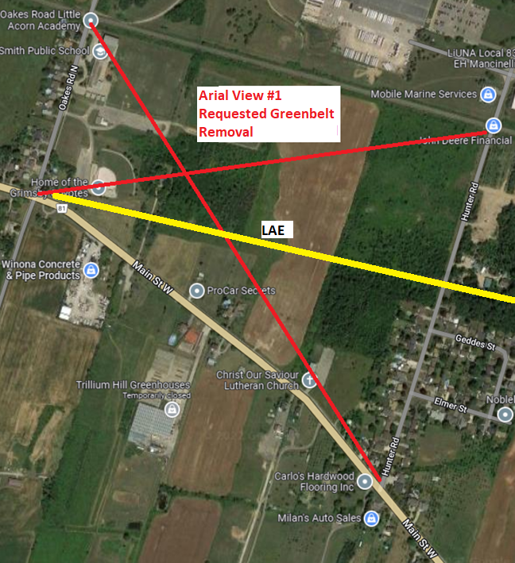

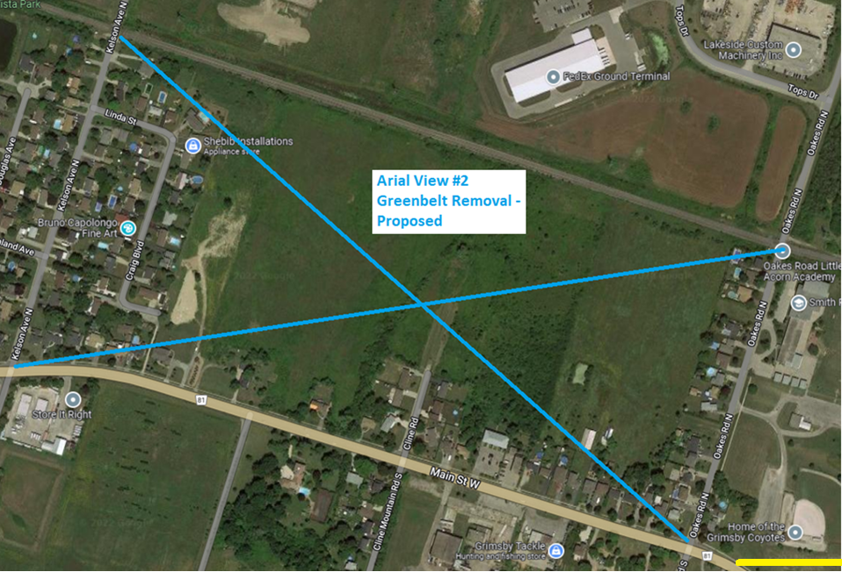

Examples of Trifunovic brothers communications made to the Town of Grimsby and Region of Niagara regarding removing lands from the Greenbelt.

Appendix 1 - Region of Niagara PIC Webinars Q & A Session Feedback - June 2021

<https://www.niagararegion.ca/official-plan/pdf/submissions/george-trifunovic.pdf>

The contents of the entire Feedback Session PDF are relevant but of particular interest is item:

…

36. We fully support the Niagara Region’s submission to the proposed changes to the PPS (Provincial Policy Statement) - (ERO #019-0279). In particular under the ITEMS FOR CONSIDERATION and PDS31-2019 - Proposed Changes to the PPS to create Specialty Crop Area Guidelines: “The definition for “specialty crop area” – which remains unchanged in the draft PPS – mentions that areas are designated using guidelines developed by the Province. Niagara has a significant portion of land designated as specialty crop area. Presently, there are many instances in Niagara where lands are designated as specialty crop area where, in fact, those lands are unsuitable for any type of agriculture-related use. The Region requests the Province to create its referenced guideline and review existing specialty crop areas to accurately reflect existing uses through ground-truthed analysis.” The Region of Niagara must submit changes to designated lands currently in the Ontario Greenbelt to allow for critical zones to be exchanged with lands outside the greenbelt to allow urban boundaries to expand where they are most needed.

…

**Appendix 2 – From Private Property Owners That Border Livingston Avenue Extension – March 11, 2019**

<https://niagararegion.ca/official-plan/pdf/submissions-jul-oct-2021/trifunovic3.pdf>

The contents of the letter to Ms. Ryall and Ms. Norio dated March 11, 2019 also includes a map:

**Re: Regarding the EA for Livingston Avenue Extension from Emily Street to Main Street West**

We have participated in the Region of Niagara Notice of Study Commencement and PIC #1 Municipal Class Environmental Assessment (EA) Studies. This was for the Casablanca Boulevard improvement and GO Station Access plus the Livingston Avenue Extension that was held on June 20, 2018.

We responded to the Region of Niagara survey’s regarding these two EA’s in the fall of 2018.

We participated in the Casablanca Boulevard improvement and GO Station Access PIC #2 on January 16, 2019.

At these sessions and the online surveys we voiced our full support to complete the improvements for the Casablanca Boulevard and GO Station access. We also fully support the completion of the Livingston Avenue extension as was originally planned since 1972.

We feel it is necessary to implement the transit improvements for these 2 projects. They will be required to meet the future traffic demands around the GO Station hub area and the high density condominium developments currently being proposed and built in the Casablanca Boulevard area of Grimsby.

We respectfully submit this letter ‘for the record’ to make notification of our request as a group of private property owners that neighbour the Livingston Avenue Extension to move forward with the improvements.

We feel very strongly the Livingston Avenue Extension must be completed from west of Emily Street directly to Main Street West at Oakes Road as was originally planned. With this EA process now under way we felt it necessary to express our point of view as a group.

Many of the properties along the approximate 1,400 meter stretch of the Livingston Avenue extension are physically divided into two parcels. The north portion of each of these lands would be land-locked along the CN rail line i.e., if the extension was not to be used as a roadway; this is of great concern to the landowners!

The proper solution would be for the Region of Niagara to complete the Livingston Avenue extension. We will be actively participating in the Livingston Avenue extension PIC #3 once it is scheduled in the spring 2019.

Please find the list of private property owners along the Livingston Avenue extension area who feel we have the right to post our views to fully support the roadway improvements – to have them noted and recognized.

The majority of private land owners that border along the Livingston Avenue extension in Grimsby are in full support of completing the Livingston Avenue roadway right of way as was originally planned

<Map Here – Open Link>

**Appendix 3 – Summary of Comments from July 6, 2018 Special Council Meeting**

Formal report New Niagara Official Plan - Public Consultation Summary

At the Region of Niagara council meeting there was report to the Planning and Economic Development Committee and:

1. That Report PDS 3-2020 BE RECEIVED for information; and

2. That a copy of Report PDS 3-2020 BE CIRCULATED to the Local Area Municipalities.

<https://www.niagararegion.ca/official-plan/pdf/report-public-consultation-summary.pdf>

Of note from this summary is the following where the Trifunovic Brothers and the next property neighbour the Lutheran Church community; each submitted requests to remove their lands from the Greenbelt Plan and complete the Livingston Avenue extension (at one point the church had plan to build a senior’s living centre at their site which could not proceed):

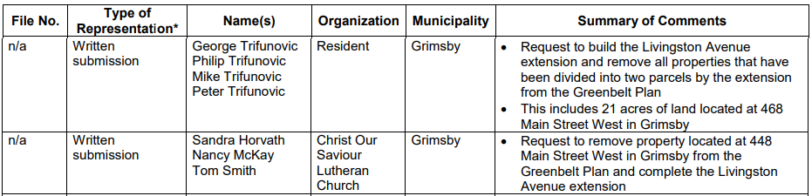

**Appendix 4 – Niagara Official Plan Consolidated Policy Report – May 12, 2021**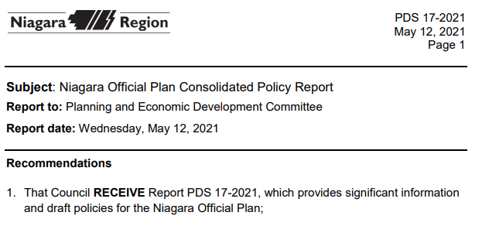

Chapter 4: Competitive Region

Below is a summary of written comments received on PDS 17-2021 between May 2021 and July 15, 2021, related specifically to the Agricultural System, Employment Areas, and Mineral Aggregate Resources. 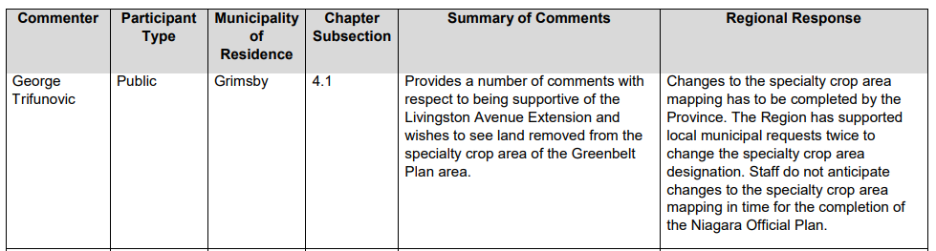

**The Web links in Appendices 1 to 3, when opened, provide additional relevant important information to the topic.**

**For further references or correspondence to the Region of Niagara or Town of Grimsby regarding Trifunovic brothers participation in Planning and/or Greenbelt feedback, please contact the Trifunovic brothers via George Trifunovic 289-700-8628 or georgetrifunovic@hotmail.com.**

1. Major Transportation Station Area's (MTSAs) are defined in the Provincial Growth Plan as “The area including and around any existing or planned **higher order transit station** or stop within a settlement area; or the area including and around a major bus depot in an urban core. MTSA's generally are defined as the area within an approximate 500 to 800 metre radius of a transit station, representing about a 10-minute walk.
2. On May 21, 2019, the Town of Grimsby had a recorded vote on the establishment of a GO Train Station on Casablanca Blvd. Two of eight councillors voted against the motion.

   At Council Meeting on June 20, 2020, the Town of Grimsby included Agenda Item i) to have the town lawyer submit a Part II Order to block completion of the region’s LAE AE.